**Ideation Phase**

**Define the Problem Statements**

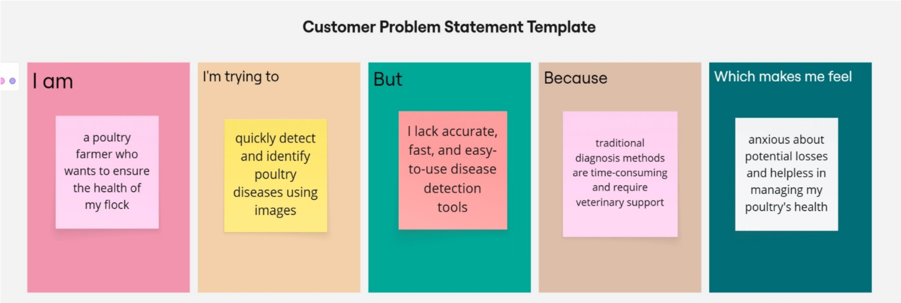

|  |  |
| --- | --- |
| Date | 30 June 2025 |
| Team ID | LTVIP2025TMID37158 |
| Project Name | Transfer Learning-Based Classification of Poultry  Diseases for Enhanced Health Management |
| Maximum Marks | 2 Marks |

**Define Problem Statements (Customer Problem Statement Template):**

Poultry farmers face challenges in the early detection and classification of poultry diseases due to the lack of accessible, fast, and accurate diagnostic tools. This delay in disease identification leads to health deterioration, increased mortality, and financial loss. There is a need for an automated, image-based system using deep learning models to assist farmers and veterinary professionals in quickly diagnosing poultry diseases and improving overall farm management.

|  |  |  |  |  |  |
| --- | --- | --- | --- | --- | --- |
| **Problem**  **Statement**  **(PS)** | **I am**  **(Customer)** | **I’m trying to** | **But** | **Because** | **Which makes me feel** |
| PS-1 | a poultry farmer who wants to ensure the health of my  flock | quickly detect and identify poultry diseases using images | I lack accurate, fast, and easy-touse disease detection tools | traditional diagnosis methods are timeconsuming and require veterinary support | anxious about potential losses and helpless in managing my poultry's health |
| PS-2 | a poultry farm owner managing hundreds of birds. | monitor the health of my poultry and detect diseases before they spread. | I rely on physical  symptom s that appear only in later stages of infection. | I don't have access to a fast, AIbased disease detection system. | stressed and uncertain, fearing potential outbreaks and loss of income. |